# Programming Assignment 1

### Mark Forte + Paloma González

## Part 1

SaveActivity as the main activity

## Part 3

Sequence Diagram

Filtered Log

## Part 4

Images in correct folder

Layout of recycler view holder with static image

Dynamically assigned team labels. Team A has the yellow background. Team B has the white

## Part 5

Table populated from database

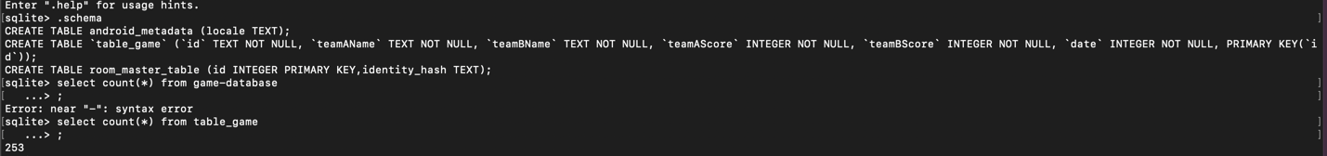

Database with 100 original entries plus 150 generated plus 3 test entries